Online Einkaufen bei IKEA
Save this document to your student number. Save it as MeinWohnzimmer
Go onto http://www.ikea.com/de/de/
MAKE SURE PAGE IS IN GERMAN. DO NOT TRANSLATE TO ENGLISH!!
You will be “buying” living room furniture. Click on the Wohnzimmer tab at the top.
You will be looking for different items. When you find an item in that category that you really like, copy and paste the picture of it into this document.
Then write 3 sentences about it (2 sentences with the furniture as the subject/1 sentence with the furniture as the direct object.) See examples and guidelines below.
Remember: der den in your direct object sentence!!!!

Example: der Korb
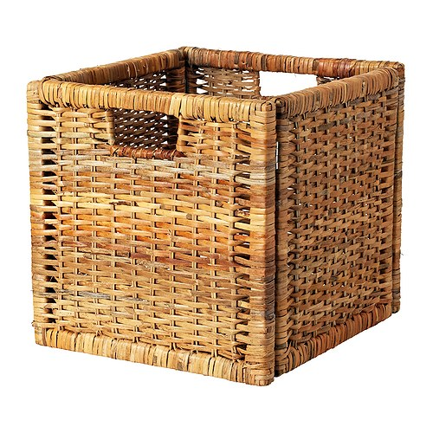
2 Subject Sentences
1. Der Korb ist beige. (Tell color)
2. Der Korb kostet 12,99 Euro. (Tell how much it costs)
1 Direct Object sentence
3. Ich finde den Korb ordentlich und praktisch. (Tell what you think of it with 2 adjectives)

You must buy:
das Sofa, der Couchtisch, 2 Lampen (die Lampe), der Sessel, der Teppich (click on Wohntextilien), das Kissen (click on Wohntextilien), das Bücherregal (click on Aufbewährung, then Regale), und die TV-Bank

